Originally produced on Broadway by: Joey Parnes, Larry Hirschhorn, Joan Raffe/ Jhett Tolentino, Martin Platt & David Elliot, Pat Flicker Addiss, Catherine Adler, John O’Boyle, Joshua Goodman, Jamie de Roy/Richard Winkler, Cricket Hooper, Jiranek/ Michael Palitz, Mark S. Golub & David S. Golub, Radio Mouse Entertainment, Shawdowcatcher Entertainment, Mary Cossette/ Barbara Manocherian Megan Savage. Meredith Lynsey Schade, Hugh Hysell/Richard Jordan, Cheryl Wiesenfeld/Ron Simons, S.D. Wagner, John Johnson in association with McCarter Theatre and Lincoln Center Theater

Originally commissioned and produced by McCarter Theatre Center, Princeton, N.J. Emily Mann, Artistic Director; Timothy J. Shields, Managing Director; Mara Isaacs, Producing Director; and produced by Lincoln Center Theater, New York City under the direction of Andre Bishop and Bernard Gersten in 2012.

“Here Comes the Sun”
Written by George Harrison
Plublished by Harrisongs, Ltd. (ASCAP)
Used by Permission. All Rights Reserved.

ABOUT SIERRA CLASSIC THEATRE
Sierra Classic Theatre Company was founded in 1999 with the mission of providing our community with quality performances of renowned plays. SCT is a 501(c)3 non-profit group. Our goal is to create an artistically adventurous environment that attracts and excites diverse members of the community by providing an expanded understanding of life through the art of quality theatre.

ABOUT THE PLAY
Winner of the 2013 Tony Award for Best Play, Christopher Durang originally wrote the part of Masha for Sigourney Weaver. The two were classmates at Yale Drama School and have been friends since. Sigourney Weaver was in the original production opposite David Hyde Pearce as Vanya.

PLACE
A lovely farmhouse in Bucks County, Pennsylvania.

TIME
The present.

Allison McDonell Page (Director/ Masha) A former actress in New York City and Los Angeles, Allison directed Proof, August: Osage County, Merry Wives of Windsor and Twelfth Night for Sierra Classic Theatre and Sleuth for Mammoth Lakes Rep. Allison has been a member of the Sierra Classic Theatre Board for the last 5 years. When not drilling her actors, or changing her hair color, Allison works as a Realtor at Snowcreek, and part-time ski instructor at the mountain. Allison is a huge fan of the playwright, and feels so fortunate to be able to work with such dedicated, hysterical, and amazingly talented actors. A special thank you to my tireless friends and family who have supported me throughout.

Chuck Scatolini (Assistant Director/ Vanya) This is Chuck's second Christopher Durang comedy. He played a socially inept shrink in Durang's Beyond Therapy produced by SCT in Mammoth a few years back. Chuck assisted Allison as Director once before in, August: Osage County and is happy to be partners once again. Keenly aware of certain ironic real-life coincidences he shares with Vanya, (Chuck, too, does not own a cell phone) Chuck persists in the belief that life-imitates-art and vice versa. Thanks to this funny cast for not making "rehearsals an enormous trial" and for taking "a leap of faith.”

Kathy Steele (Sonia) Like Sonia, “I don't want to go to Moscow. I like it here," was Kathy's mantra from 1993 through 1997 when she actually did live in Moscow, Russia and was the Head of the English Department at the U.S. Embassy School there. Kathy received her B.A. In Theater and English back when we were all licking postage stamps. She went on to teach theater all across the globe. In her spare time, she raised a family, acted in Community Theater, and joined a ski club. Now Kathy and her boyfriend John split their time between Mammoth Lakes and Pismo Beach. She thoroughly enjoyed working with this energetic cast. "Thanks for a cheeky good time” as Maggie Smith might say on the way to the Oscars!

Pricilla Toledo (Cassandra) is one of a small number of people who can honestly say she was born and raised in Mammoth Lakes. She has been acting since Mammoth High school and has worked with both SCT and Mammoth Rep. in To Kill A Mockingbird, August: Osage County (at The Edison) and The Complete Works of William Shakespeare (at Sam’s Woodsite.) She loves playing Cassandra because she reminds her of all the wonderfully zany people in her life! "Oh, Wretches!"

Jimmy Davoren (Spike) Jimmy immediately auditioned for this play when he realized he might get to take his clothes off and would be constantly referred to as "attractive." This is his third play in Mammoth since moving here in 2013. He was in "Twelve Angry Jurors" with quite a bit of clothing and a very different personality. Before that, Jimmy played Demetrius in "A Mammoth Midsummer Night's Dream." Jimmy may not understand all of Christopher Durang's hoity-toity literary references, but at least he, unlike Spike, can read a book. He'd like to thank the rest of the cast for the fun and the superior focus.

Cassandra Burgenbauch (Nina) Cassie grew up in Mammoth Lakes and attended Occidental College in Los Angeles, graduating with a degree in music and Spanish. She has been involved in a variety of productions in Mammoth, including Into the Woods, By the Skin of Our Teeth, Fiddler on the Roof, and most recently, ML Repertory Theatre's production of The Winter Wonderettes. When she's not onstage, you can find Cassie restocking books at the Booky Joint, teaching violin with Chamber Music Unbound, or jamming with the Bodie 601 Band. Many thanks to her wonderful family and friends and this incredibly talented cast!

Christopher Durang (Playwright) is an American playwright known for works of outrageous and often absurd comedy. His plays have been performed nationwide, including on Broadway and Off-Broadway. His works include Sister Mary Ignatius Explains It All For You, Beyond Therapy, The Marriage of Bette and Boo, and many, many more.

SPECIAL THANKS TO…..

Camille Miller, Ted Carlton, The Snowcreek Property Company, Julie Wright, Beckett Page, Eva Howell, Jude Howell, John Walker, Marlene Piper, Shira Dubrovner, Sean, Carol, Deanna Clark, Carol Sutorius, Shaun Reitman, Barbara Covert, Guy Sassin, Elise Howell, Jennifer Holmes, Karrah Spitznagel, and Marlene Piper.

THANK YOU TO OUR DONORS!

Jim Harnagal, Alex Printing

2015 BOARD OF DIRECTORS

Chuck Scatolini, King
Allison McDonell Page, Scribe
Jim Marcotte, Joker
Jennifer Chase, Minister of Finance
Mike Dostrow, Jester

DON’T MISS A SINGLE SCT EVENT!

August 6,7,8,9 & 13,14,15, 16,
SCT’s Shakespeare in the Woods
TWO GENTLEMAN OF VERONA
Sponsored by Mammoth Lakes Recreation

Fall Murder Mystery November 5-16
at Tom’s Place, Lakanuki, and the Rock n Bowl

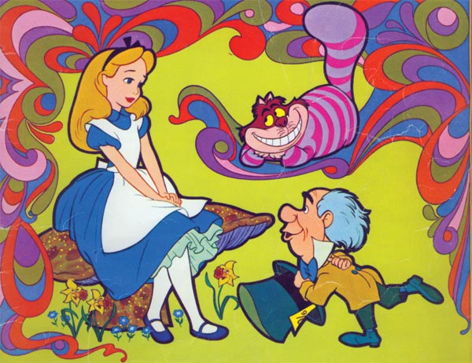
SCT’s Mammoth Children’s Theater
Performances December 4 & 5 at The Edison
Sponsored by Mammoth Lakes Recreation

www.sierraclassictheatre.com
“Like” us on Facebook.com/SierraClassicTheatre
Want to get involved: email thesierraclassictheatre@gmail.com

